LAB NO:02

Object: Text basics, formatting texts.

Introduction
If you're new to Microsoft Word, you'll need to learn the basics of typing, editing, and organizing text. Basic tasks include the ability to add, delete, and move text in your document, as well as how to cut, copy, and paste.

Using the insertion point to add text
The insertion point is the blinking vertical line in your document. It indicates where you can enter text on the page. You can use the insertion point in a variety of ways.
- Blank document: When a new blank document opens, the insertion point will appear in the top-left corner of the page. If you want, you can begin typing from this location.
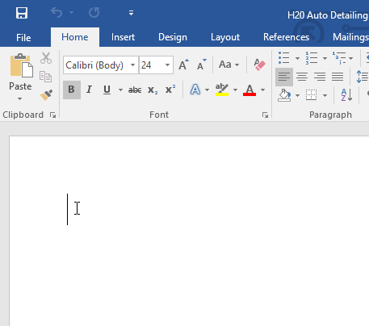
- Adding spaces: Press the spacebar to add spaces after a word or in between text.


- New paragraph line: Press Enter on your keyboard to move the insertion point to the next paragraph line.

- Manual placement: Once you begin typing, you can use the mouse to move the insertion point to a specific place in your document. Simply click the location in the text where you want to place it.

- Arrow keys: You can also use the arrow keys on your keyboard to move the insertion point. The left and right arrow keys will move between adjacent characters on the same line, while the up and down arrows will move between paragraph lines. You can also press Ctrl+Left or Ctrl+Right to quickly move between entire words.
In a new blank document, you can double-click the mouse to move the insertion point elsewhere on the page.

Selecting text
Before you can move or format text, you'll need to select it. To do this, click and drag your mouse over the text, then release the mouse. A highlighted box will appear over the selected text.
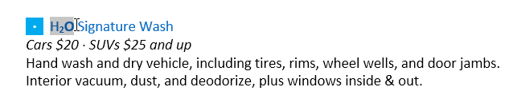

When you select text or images in Word, a hover toolbar with command shortcuts will appear.If the toolbar does not appear at first, try hovering the mouse over the selection.
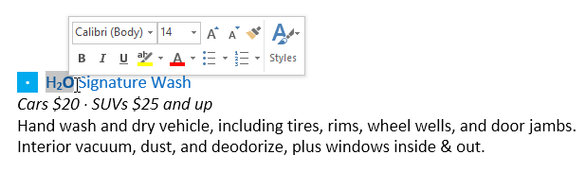

To select multiple lines of text:
- Move the mouse pointer to the left of any line so it becomes a right slanted arrow.
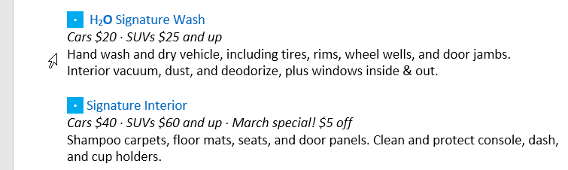
- Click the mouse. The line will be selected.
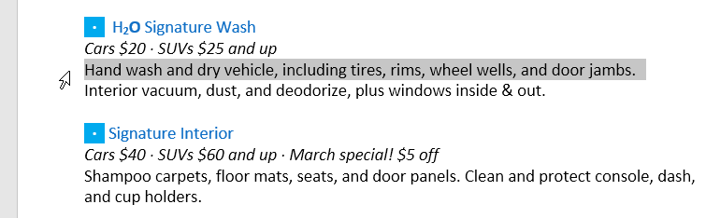
- To select multiple lines, click and drag the mouse up or down.
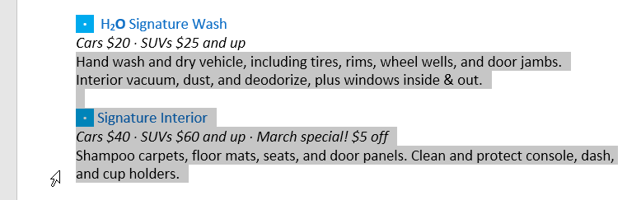

- To select all of the text in your document, choose the Select command on the Home tab, then click Select All. Alternatively, you can press Ctrl+A on your keyboard.
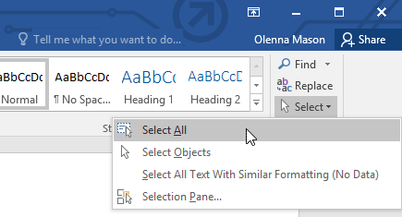
Other shortcuts include double-clicking to select a word and triple-clicking to select an entire sentence or paragraph.

To delete text:
There are several ways to delete—or remove—text:
- To delete text to the left of the insertion point, press the Backspace key on your keyboard.
- To delete text to the right of the insertion point, press the Delete key on your keyboard.
- Select the text you want to remove, then press the Delete key.
If you select text and start typing, the selected text will automatically be deleted and replaced with the new text.

Copying and moving text
Word allows you to copy text that's already in your document and paste it in other places, which can save you a lot of time and effort. If you want to move text around in your document, you can cut and paste or drag and drop.

To copy and paste text:
- Select the text you want to copy.
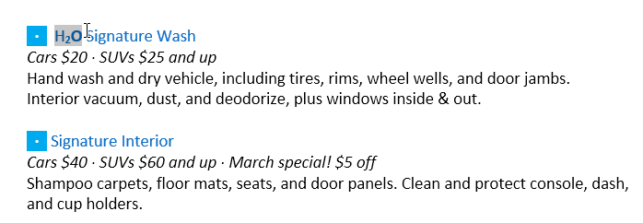
- Click the Copy command on the Home tab. Alternatively, you can press Ctrl+C on your keyboard.
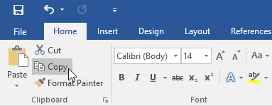
- Place the insertion point where you want the text to appear.
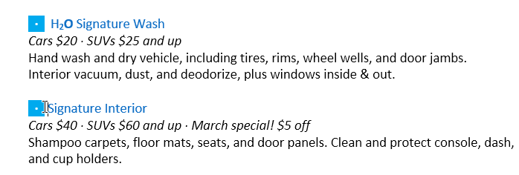
- Click the Paste command on the Home tab. Alternatively, you can press Ctrl+V on your keyboard.
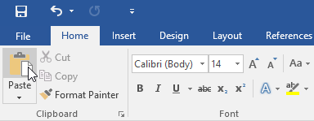
- The text will appear.
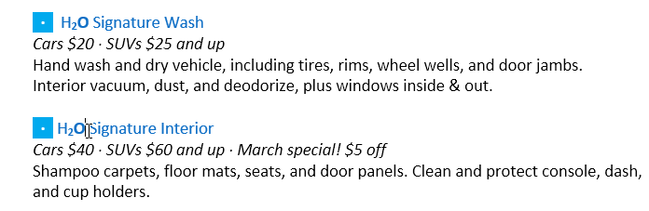

To cut and paste text:
- Select the text you want to cut.

- Click the Cut command on the Home tab. Alternatively, you can press Ctrl+X on your keyboard.
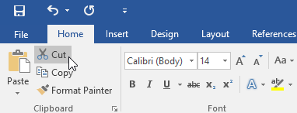
- Place your insertion point where you want the text to appear.
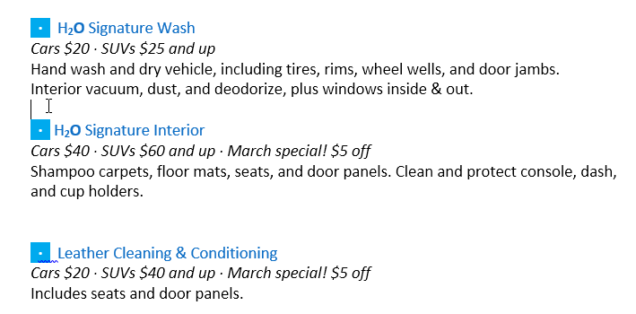
- Click the Paste command on the Home tab. Alternatively, you can press Ctrl+V on your keyboard.

- The text will appear.
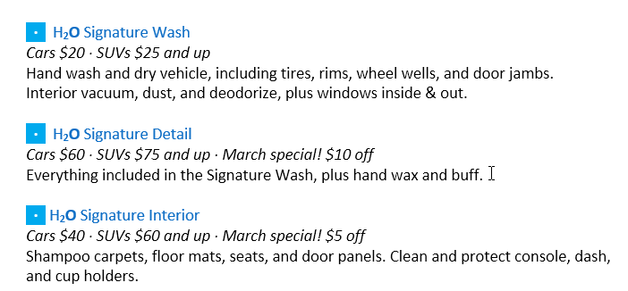
You can also cut, copy, and paste by right-clicking your document and choosing the desired action from the drop-down menu. When you use this method to paste, you can choose from three options that determine how the text will be formatted: Keep Source Formatting, Merge Formatting, and Keep Text Only. You can hover the mouse over each icon to see what it will look like before you select it.

To drag and drop text:
- Select the text you want to move.
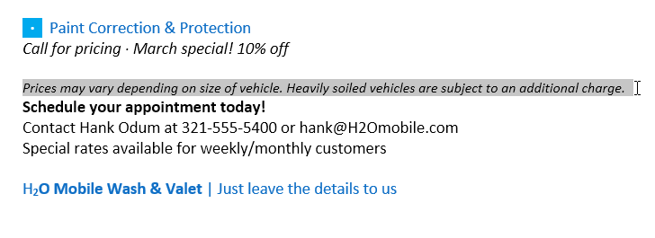
- Click and drag the text to the location where you want it to appear. A small rectangle will appear below the arrow to indicate that you are moving text.
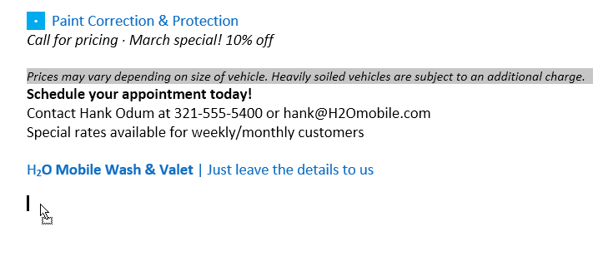
- Release the mouse, and the text will appear.
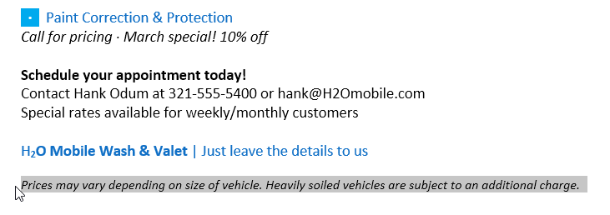
If text does not appear in the exact location you want, you can press the Enter key on your keyboard to move the text to a new line.

Undo and Redo
Let's say you're working on a document and accidentally delete some text. Fortunately, you won't have to retype everything you just deleted! Word allows you to undo your most recent action when you make a mistake like this.
To do this, locate and select the Undo command on the Quick Access Toolbar. Alternatively, you can press Ctrl+Z on your keyboard. You can continue using this command to undo multiple changes in a row.
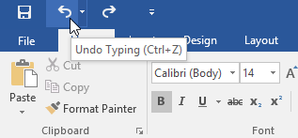
By contrast, the Redo command allows you to reverse the last undo. You can also access this command by pressing Ctrl+Y on your keyboard.
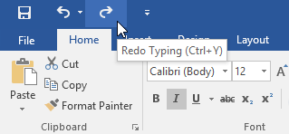

Symbols
If you need to insert an unusual character that's not on your keyboard, such as a copyright (©) or trademark (™) symbol, you can usually find them with the Symbol command.

To insert a symbol:
- Place the insertion point where you want the symbol to appear.
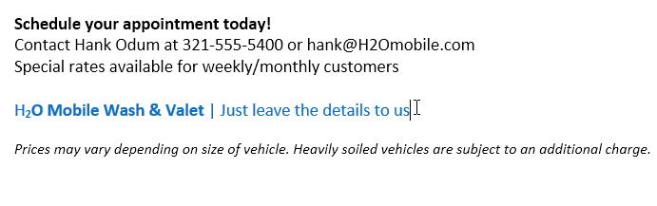

- Click the Insert tab.
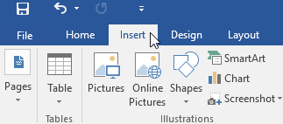
- Locate and select the Symbol command, then choose the desired symbol from the drop-down menu. If you don't see the one you want, select More Symbols.
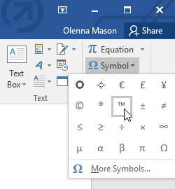
- The symbol will appear in the document.
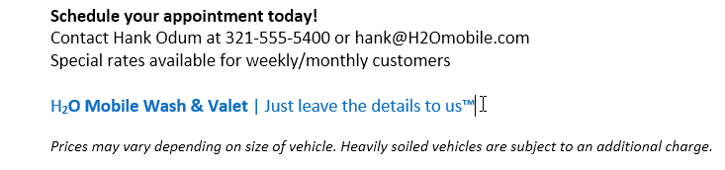

- Using find and replace

Introduction
Formatted text can draw the reader's attention to specific parts of a document and emphasize important information. In Word, you have several options for adjusting text, including font, size, and color. You can also adjust the alignment of the text to change how it is displayed on the page.

To change the font size:
- Select the text you want to modify.
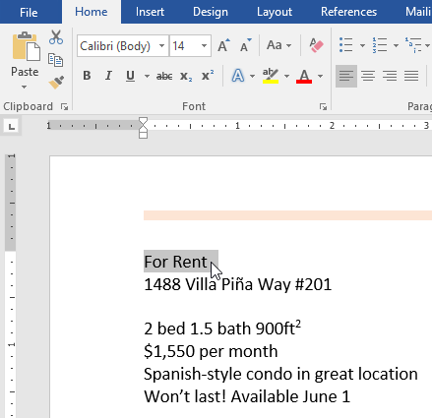
- On the Home tab, click the Font size drop-down arrow. Select a font size from the menu. If the font size you need is not available in the menu, you can click the Font size box and type the desired font size, then press Enter.
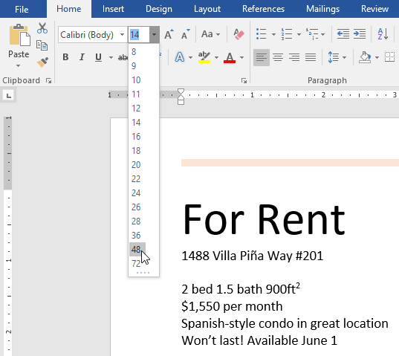
- The font size will change in the document.
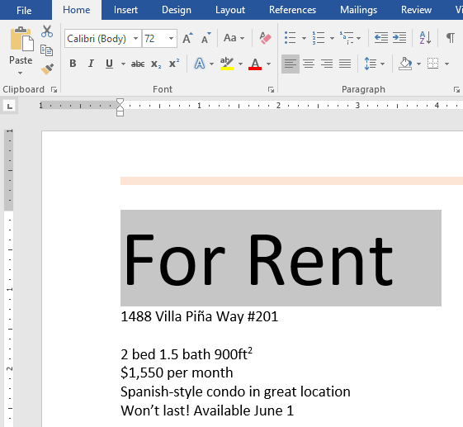
You can also use the Grow Font and Shrink Font commands to change the font size.
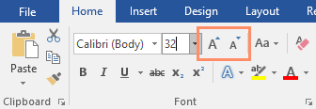

To change the font:
By default, the font of each new document is set to Calibri. However, Word provides many other fonts you can use to customize text.
- Select the text you want to modify.
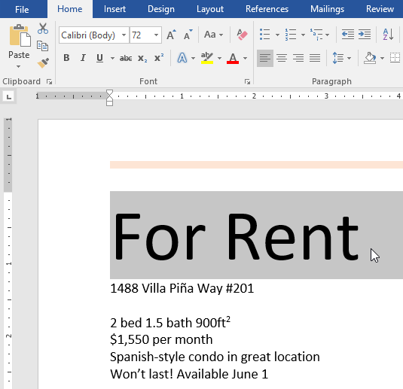
- On the Home tab, click the drop-down arrow next to the Font box. A menu of font styles will appear.
- Select the font style you want to use.
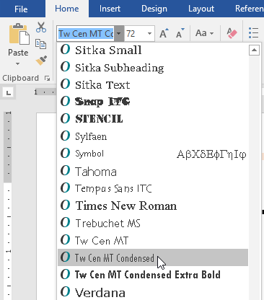
- The font will change in the document.
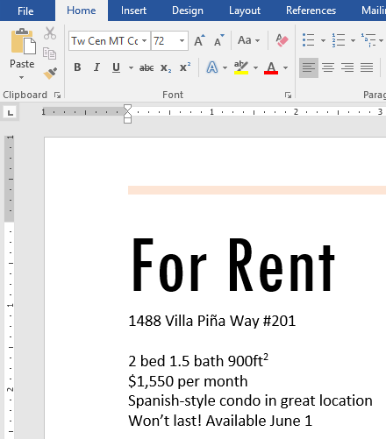
When creating a professional document or a document that contains multiple paragraphs, you'll want to select a font that's easy to read. Along with Calibri, standard reading fonts include Cambria, Times New Roman, and Arial.

To change the font color:
- Select the text you want to modify.
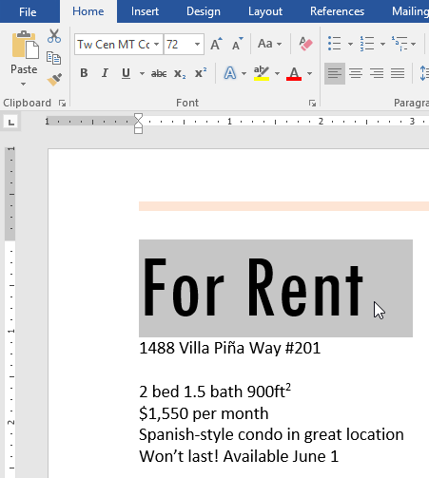
- On the Home tab, click the Font Color drop-down arrow. The Font Color menu appears.
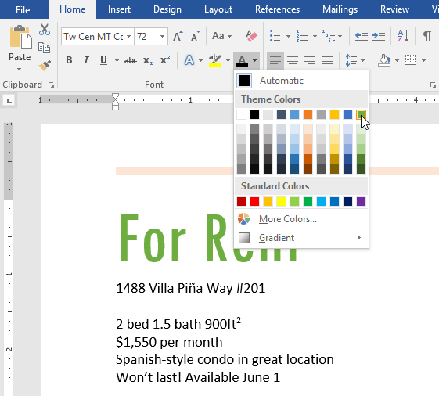
- Select the font color you want to use. The font color will change in the document.
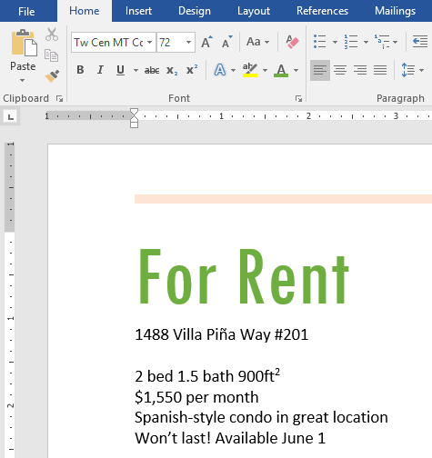
Your color choices aren't limited to the drop-down menu that appears. Select More Colors at the bottom of the menu to access the Colors dialog box. Choose the color you want, then click OK.
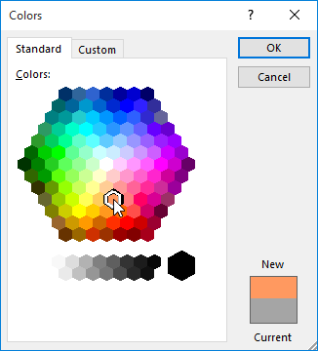

To use the Bold, Italic, and Underline commands:
The Bold, Italic, and Underline commands can be used to help draw attention to important words or phrases.
- Select the text you want to modify.
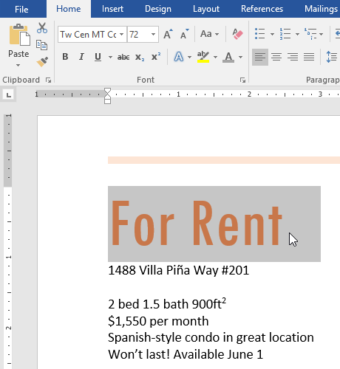
- On the Home tab, click the Bold (B), Italic (I), or Underline (U) command in the Font group. In our example, we'll click Bold.
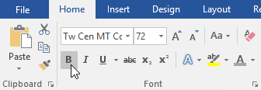
- The selected text will be modified in the document.
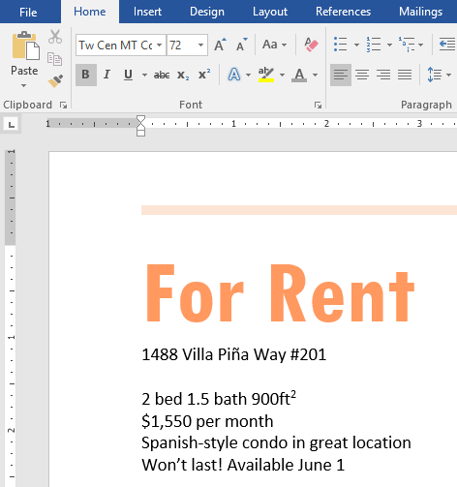

To change text case:
When you need to quickly change text case, you can use the Change Case command instead of deleting and retyping text.
- Select the text you want to modify.
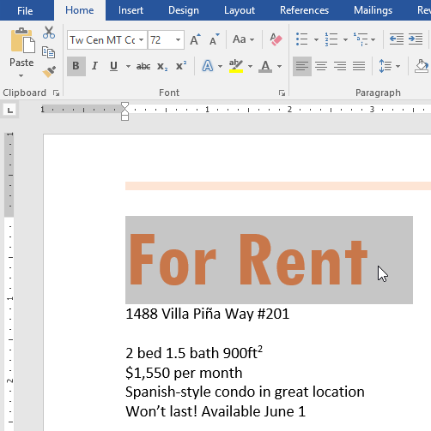
- On the Home tab, click the Change Case command in the Font group.
- A drop-down menu will appear. Select the desired case option from the menu.
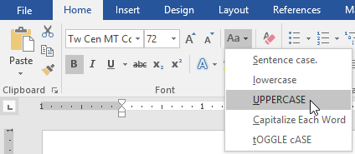
- The text case will be changed in the document.
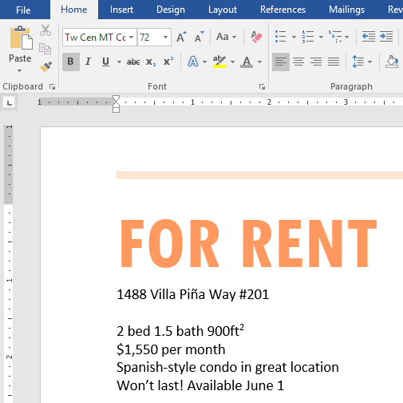

To highlight text:
Highlighting can be a useful tool for marking important text in your document.
- Select the text you want to highlight.
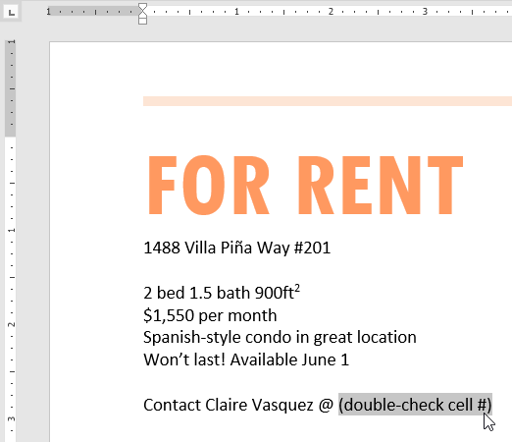
- From the Home tab, click the Text Highlight Color drop-down arrow. The Highlight Color menu appears.
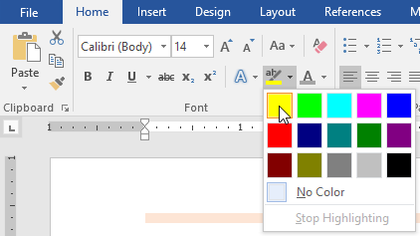
- Select the desired highlight color. The selected text will then be highlighted in the document.
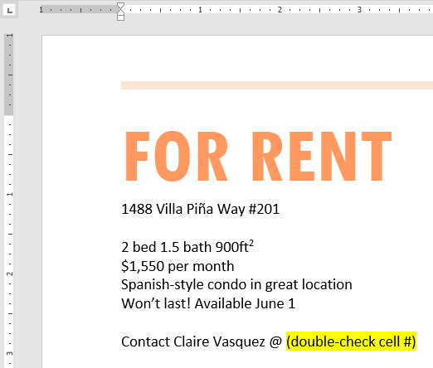
To remove highlighting, select the highlighted text, then click the Text Highlight Color drop-down arrow. Select No Color from the drop-down menu.
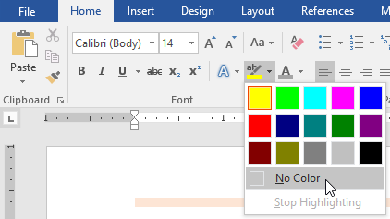
If you need to highlight several lines of text, changing the mouse into a highlighter may be a helpful alternative to selecting and highlighting individual lines. Click the Text Highlight Color command, and the cursor changes into a highlighter. You can then click and drag the highlighter over the lines you want to highlight.

To change text alignment:
By default, Word aligns text to the left margin in new documents. However, there may be times when you want to adjust text alignment to the center or right.
- Select the text you want to modify.
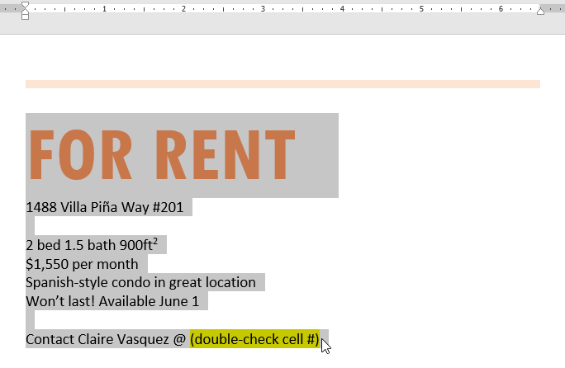
- On the Home tab, select one of the four alignment options from the Paragraph group. In our example, we've selected Center Alignment.
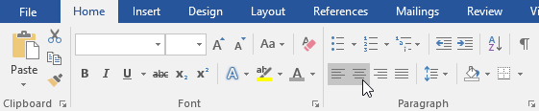
- The text will be realigned in the document.
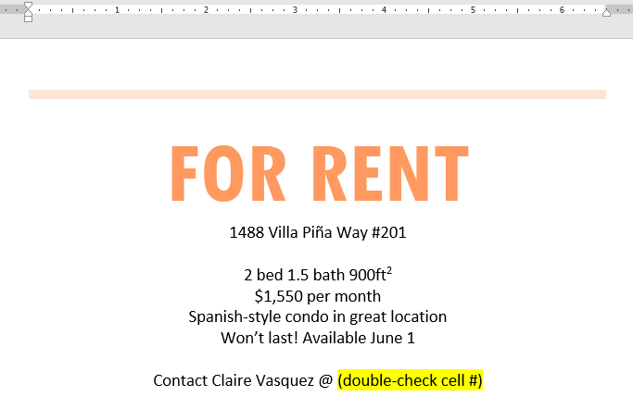
Click the arrows in the slideshow below to learn more about the four text alignment options.
arrow_back_ios

- Align Text Left: This aligns all selected text to the left margin. The Align Text Left command is the most common alignment and is selected by default when a new document is created.

- Center: This aligns text an equal distance from the left and right margins.

- Align Text Right: This aligns all selected text to the right margin.

- Justify: Justified text is equal on both sides. It lines up equally to the right and left margins. Many newspapers and magazines use full justification.

arrow_back_ios
You can use Word's convenient Set as Default feature to save all of the formatting changes you've made and automatically apply them to new documents. To learn how to do this, read our article on Changing Your Default Settings in Word.

Tasks:
- Place the insertion point at the top of the document and type Now Introducing...
- Use your arrow keys to move the insertion point to the Signature Detail Plan's price and change it to $99.99/mo.
- At the end of the line you just moved, insert trademark symbol , coyright and pie’s symbol. If you cannot find the trademark symbol, insert a different symbol of your choice.
- Take a random text or paragraph from internet and align it in center first, align it left . align it right and then justify it. Copy paste the snapshots accordingly.

